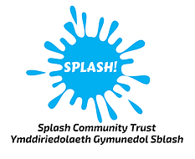

**RLSS ASSISTANT POOL SUPERVISOR – 35 hours per week @ £12.40 per hour**

**Closing date for applications: Friday 24th January 2025**

You will be required to work evenings, weekends and bank holidays

We are looking for an Assistant Pool Supervisor to join our team at Plas Madoc Leisure Centre. The role is to provide frontline supervision of the pool and to ensure the efficient and effective operation within the pool area.

We are looking for an enthusiastic, motivated person who can work as part of a team, have the ability to lead a team and provide excellent customer service. Your duties will include promoting a safe pool environment, ensure health & safety requirements are met, assist in the upkeep of the cleaning and maintenance procedures within the pool area, adhere to the Centre’s policy for Health & Safety, must be able to work unsupervised at times and have a flexible approach to work.

All applicants must hold a valid RLSS Pool Lifeguard qualification or STA Pool Lifeguard qualification and must be willing to attend monthly training sessions to ensure your qualification remains valid.